The First Year of

‘The Woman Engineer’

Journal

- An Analysis

by
Jacx Chan

Introduction

The Woman Engineer (TWE) is the journal published by the Women’s Engineering Society (WES), and is the first journal published about women in engineering in the UK, and arguably in the entire world. The first issue was published in December 1919, with Caroline Haslett as its founder and first editor. Caroline Haslett was also the first secretary of the WES and co-founder of the Electrical Association for Women. TWE journal was published quarterly with an initial price of 3D, although its price rose soon after owing to the economic downturn after WW1. It was initially sold at the WES office at 46 Dover Street and also sent to subscribers via post. The journal was successful; by its second year, the circulation of the journal had doubled and arrangements were made to supply it through W.H. Smith shops.

During the first year of publication each issue was on average 10 pages long, although it is noted that the average page count did increase substantially over the years. Each issue typically consisted of various types of articles (informative, argumentative, testimonial, etc) on issues relevant to women and engineering, including legislation around women in engineering, educational opportunities (academic and technical) for women in engineering, technical institutions which admitted women, science, and mathematics. There was also a regular column which started in the second issue: the ‘Views of Distinguished Engineers’ series where prominent (male) engineers endorsed women’s involvement in engineering.

What this work aims to do is study how women themselves felt and wrote about the issues affecting them in TWE. This is vitally important as research around disenfranchised groups of people tends to focus on sources written about them by external parties (namely men of high social standing) and not through their own voices.

Before discussing the bulk of the research into TWE journal, I first give a brief background on women’s labour around the time of World War I. Various topics were discussed in the first year of publication of the journal, of which I have selected a few to highlight. In the first section, I discuss the positions published in TWE on the Restoration of Pre-War Practices Act and equal pay. I have chosen to discuss the response the writers had to this act as it was the cause of the effective removal of women from engineering after the end of WWI and the catalyst for the setting up of the WES and its journal, TWE. Understanding the specific aspects of the law that the writers agreed or disagreed with would help clarify what women at the time thought about their employment in engineering and the various reasons they had for it. Besides that, I also chose to discuss the intricacies surrounding the issue of equal pay which was pertinent then in hopes that it would inform the still active discussion around it today. In the second section, I discuss the issue of women’s ‘skill’ in engineering as it was one of the main social reasons for why women at the time were not employed in engineering. In fact, many of the stereotypes about women’s suitability for engineering still persist today, and understanding how women then felt and argued against them would help inform the way we approach the issue today. In the third and final section, I discuss the strategic ways in which the writers for TWE established women’s legitimacy in engineering by emphasising three main matters: education, membership in technical institutions, and endorsements from well-respected (male) engineers. This is to give agency to women of the time who actively advocated for their place in engineering and to inspire women today who continue to do so.
Women's Labour Around the Time of World War I

Around the time of World War I (WWI), the societal ideal for women’s employment was to be unemployed; the true role of women was to be wives and mothers. Time and energy before marriage were to be spent readying herself for the role, whereas upon marriage, they were to be spent dutifully performing it. This ideal was enforced especially harshly on married women because it was believed that her work would cause her to neglect her children and be a negative reflection of her husband’s financial capability as he alone could not provide for the comforts of the family (Braybon 2012, 18). However, these ideals were unrealistic for the majority of society, and working-class women of the time had to and did work.

The societal expectation that working single women would have to leave employment upon marriage kept the bulk of the female labour force temporary and often not unionised (Braybon 2012, 128). Employers frequently exploited this, and paid women much lower wages than men which made them an economic threat to the male working class. Hence, the male working class had economic reasons for gatekeeping their professions from women and often reinforced the already present societal beliefs that womanly qualities were somehow incompatible with their ‘masculine’ jobs. Reasons such as their work being too physically demanding, rough, and dirty were used to exclude women from most sectors. Owing to this, unmarried and widowed working-class women at the time were mainly limited to employment in the traditionally feminine sectors of domestic service, clothing, and textiles (Braybon 2012, 26). On the other hand, married women who were burdened with childcare mostly worked a few hours a day as charwomen for atrocious wages (Braybon 2012, 20). The reasons, however, for the separation of labour along sex lines are not that simple. It is not enough to say that working-class men were motivated by purely economic fears, as the best weapon against unscrupulous employers would have been an undivided working class (Braybon 2012, 230). They most probably did truly believe to a certain extent that the ‘masculine’ work they were doing was fundamentally unsuitable for women. However, the limited discussion above does highlight some of the main ideas which underpinned the (exclusion of the) employment of women in various sectors at the time.

Of all the sectors, engineering was arguably one of, if not the worst, in women’s employment because the work was thought to be especially incompatible with the assumed qualities of women. The theoretical work of an engineer was not only supposed to be scientifically rigorous but to mainly involve the very branches of science that women were thought to be uninterested in or worse at such as physics and mathematics (as opposed to, for example, botany). On the other hand, the more hands-on engineering work in the factories was not only physically demanding, dirty, and rough but also believed to require ‘skill’ which women were believed to be incapable of attaining.

The main reason for the practical exclusion of women from engineering however was the skilled trades unions (the most prominent of which was the Amalgamated Society of Engineers (ASE)) which were particularly powerful in this field and could gatekeep this sector. They did this by refusing women of apprenticeship opportunities and union admission, which were necessary conditions to work in the field.

However, WWI (28 July 1914 - 11 November 1918) was a period of radical change for women and engineering. As the number of male engineering workers dwindled due to conscription, women had to be and were finally allowed entry into the field. ‘Substitution’ which is defined as the extensive use of women in place of men began in the autumn of 1915 for the engineering and explosives sectors. By 1916, there was actually a shortage of female labour in the clothing and textile trades, as women moved into more lucrative munitions work (Andrews 1921, Ch. IV). In engineering, processes and machinery were introduced or modified to ensure that production could meet the demands of the war. There was much debate on the ‘skill’ and quality of the work that women did; what can be said for certain was that the appraisal of ‘skill’ in engineering work was biassed against women and that their work was good enough to sustain the war effort (Braybon 2012, 85). It is worth discussing briefly the intersection of class with women’s engineering work during the war. The classical view of women in the engineering industry working together without class divisions during the war is mistaken. Middle- and upper-class women often were not directly involved in engineering and even when they were, they were put in higher-up roles such as women’s supervisors looking after the working class women working in the factories.

Soon after the end of WWI, women were again relegated back to their traditional roles. This was achieved legally through the Restoration of Pre-War Practices Act which was passed by the British Parliament on 2 June 1919, less than 7 months after the end of the war. The act gave employers up to two months to return to pre-war practices and then required them to be maintained for at least a year. This meant that women whose contributions were trumpeted all over the press during the war were effectively removed from the engineering field. As a response to this threat, the WES was founded in a matter of days on 23 June 1919 and it published the first issue of The Woman Engineer journal in December of that same year.

- Positions and Positionality

TWE’s position on women’s employment in engineering is most directly expressed in an article titled ‘Restoration of Pre-War Practices Act’, where two quotations are reproduced at the article’s very start as seen in the excerpt below.

“Redemption of pledges is a national duty of course, just as it is an individual virtue. But, having the right to claim redemption of a pledge is one thing, and the wisdom of enforcing that right is quite another thing. . . . The pledge was given for the protection of trade union members, and surely before persons are deprived of their means of livelihood there should be some prejudice to the union members. If the women are not depriving males of employment, it does seem rather hard upon these women workers that they should be thrown out of work merely because, as a purely academic question, it was not the practice before the war in a particular establishment for women to be employed on a particular class of work.” - Glasgow Herald, 26/12/19.

“We made a strong, but unsuccessful, effort to retain in our services three women who were specially adapted to do a particular piece of work for which no substitutes have yet been found. These women are now receiving unemployment benefit.” - Extract of letter from an Engineering Firm (Haslett 1920, 19).

From the reviews above which they ‘hardly think it necessary to comment upon’, it is clear that TWE was not opposed to the Restoration of Pre-War Practices Act itself, but rather the wanton enforcement of it. The trade unions exploited the law not only to reclaim the jobs of men who had temporarily left them to fight for the war (which TWE agreed with) but to remove women from the field entirely. TWE believed that if women were not depriving men of their jobs, they should be allowed employment in the field.

It is difficult to determine whether the original intention of the law was to protect only the interest of the men who fought in the war or the entire engineering sector, and hence whether it had been unfairly enforced. Regardless, TWE further argued that the wanton enforcement of the law was detrimental to various parties. From the extract of a letter from an engineering firm above, TWE brought forward a real-life example of the blanket removal of women from engineering work being economically harmful; not only did it deny women of jobs, but it hurt the production of employers, and by extension, the economy of the country too.

TWE also asserted that the wanton enforcement of the Restoration of Pre-War Practices Act ran contrary to the values of the country, as well, writing:

In one particular case where the women have been dismissed it has been necessary to pay-off a number of the men also, as the work which the women did could not be done as quickly by men. This short-sighted policy which forces men as well as women into unemployment cannot surely be long tolerated by a country whose watchwords have always been freedom and progress (Haslett 1920, 29).

As for the terms of employment for women in engineering, TWE was a proponent of equal pay. Its reasoning for this position is expressed clearly in the following excerpt from the article titled ‘Impressions from Kirkcudbright’..

Another speaker suggested that our only available weapon against the men’s Trade Unions in their present attitude is to accept employment at a rate lower than the present standard. To follow this advice would be to court disaster for several reasons. First: It would lower our status as workers; it being a well-known fact that the more intelligent the worker, the higher her standard of living becomes. Also it would tend to widen the breach already existing between the men’s Trades Unions and ourselves, and it would undo the work of years that the Women’s Trades Unions have done in raising women’s wages to their present standard (Haslett 1920, 13).

From the excerpt above, it is clear that TWE saw equal pay not only as an essential element of equality but also as a long, continuous struggle with an important legacy. It is noted that equal pay was not merely a matter of economics, but was inextricably linked to the status and the sociopolitical standing of women. Access to the same high wages paid to men engaged in engineering work not only meant liberation from the shackles of marriage which was hitherto oftentimes her only viable economic option but recognition of her equal contribution to the country. Many saw the granting of the vote to women as an acknowledgment of the equal role she played with men in serving the country during the war.

From our contemporary perspective, we may be quick to conclude that equal pay is necessarily a positive thing and that all supporters of it had the best interest of women in mind. Hence, it may initially come as a shock to some that the skilled trades unions were fervent supporters of women’s equal pay in engineering. It would be less shocking to find out that it was because they believed equal pay ultimately best served the interests of men. The skilled trades unions believed that the main incentive for hiring women was the cheapness of their labour and that equal pay would tip the scale definitively in favour of men who were thought to be more dependable and ‘skilled’. It is interesting to note however that this position on equal pay was contradictory to the other beliefs the skilled trades unions held. The skilled trades unions frequently justified their high pay based on the ‘skill’ their jobs required which they asserted was difficult to attain; yet they were obliged to admit that women could do certain jobs as well as they could to justify demands for equal pay. In addition, equal pay was directly contrary to the traditional acceptance of higher wages for male 'breadwinners' and lower wages for female 'dependents', although it is noted that single men were not paid any less than their married male counterparts on the same work. This was why the optimal solution for the skilled trades unions was the removal of women from engineering which they enforced as soon as the war ended (Braybon 2012, 79).

On the other hand, many people were against equal pay as they believed that it was idealistic, impractical, and could be used as a pretence of magnanimity to keep women out of employment. Hence, the intention and reasoning behind one’s stance on equal pay revealed more about their feelings towards women’s presence in engineering than the stance itself.

It is a timely opportunity now to discuss the positionality of TWE and the influence of class in influencing the position it took on supporting equal pay. The group of women who founded the WES which published TWE was generally speaking of the middle or upper classes and had access to sufficient financial resources which allowed them to support the society’s activities. They mostly had close connections to the engineering industry, be it through their husband or family, and access to higher education or training opportunities. Take for example the first president of the WES, Rachel Mary Parsons. She was the daughter of Sir Charles Algernon Parsons, a successful engineer and founder of the eponymous engineering firm C. A. Parsons and Company. He was the youngest son of William Parsons, the 3rd Earl of Rosse, a successful astronomer, engineer, and the 27th President of the Royal Society. Rachel Parsons was also one of the first three women to study Mechanical Sciences at Newnham College, Cambridge. The important thing to note from this is that the backgrounds of the people in charge of the WES and TWE were vastly different from that of the working-class women who made up the majority of the women brought into and subsequently excluded from the engineering industry. Although these considerable differences would have contributed to the two groups of women having differing positions on the same issues, only the beliefs of the former would be published in TWE and hold relative weight in society. In the example of equal pay, it is possible that TWE was biassed in favour of it due to the class and economic background of the people in charge of it. They would have been more able to refuse engineering work on an ideological basis whereas it would be extremely impractical for working-class women to do so, especially when compounded with the dire pay and conditions of the traditionally ‘feminine’ jobs.

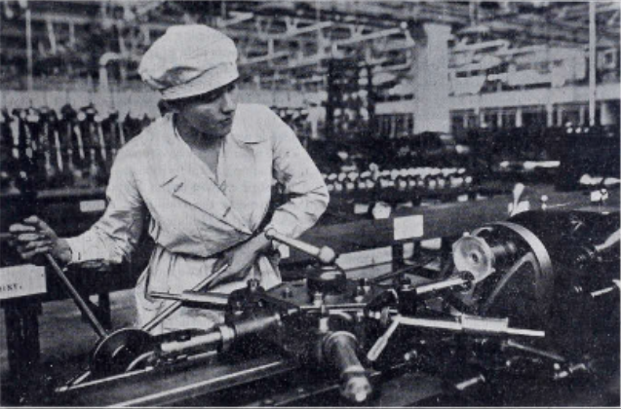
Figure 1: Cover photo of TWE’s third issue showing a woman boring the body of a magneto on a No. 4 Herbert Turret Lathe (Haslett 1920, 21)

- ‘Skill’

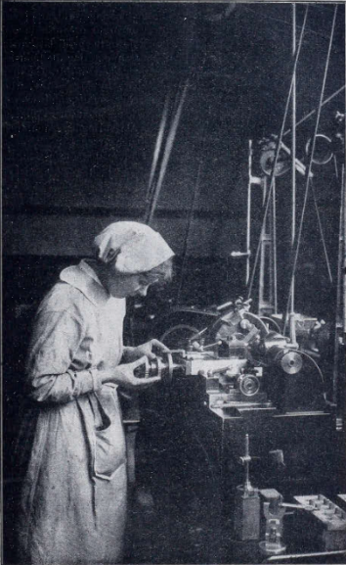
The large amount of space in TWE dedicated to discussing, directly and indirectly, women’s ‘skill’ in engineering makes it clear that TWE considered this topic to be an important one at the time. The skilled trades unions asserted that women were not only uninterested in attaining ‘skill’ but that they fundamentally were unable to, and used this as one of the main grounds for excluding women. It is important to note here too that this issue affected all women regardless of class as ‘skill’ was believed to be a sex attribute and not a socioeconomic one.
Figure 2: Cover photo of TWE’s second issue showing a woman operating the "Alfred Herbert" Precision Lathe (Haslett 1920, 9)

TWE strategically and rightly pointed out the many instances when women did perform engineering work hitherto performed by ‘skilled’ men, usually with less time and training where ‘nearly all the operators are able to look after their own machines when they have been on them a short time’ (Haslett 1920, 25) and ‘learning in a few short weeks what generally takes two or three years to master’ (Haslett 1920, 17).

Authors also used specific and technical language in detailing exactly the examples of ‘skilled’ work performed by women to grant women engineers authority and legitimacy. Descriptions such as this was included in early articles to reinforce the authority and skill of women engineers.

...set up for themselves from drawings, grinding, and even making some of their own tools, and working in some cases to one-thousandth of an inch, making parts for meters, such as jewel screws, etc., on small capstans... (Haslett 1920, 24).

The TWE also used photographs as a different medium of women working to emphasise their skill. The front covers of three of the first four issues shown in the figures interspersed throughout this document show women hard at work in a workshop or factory setting handling complex machinery.

By providing multiple verifiable examples of ‘skilled’ work performed by women, TWE was able to inductively prove that women could and did in fact possess ‘skill’ and qualities that made them particularly suitable for engineering, as they pointed out that ‘their practical minds and quickness to seize on new ideas are specially adapted to this profession’ (Haslett 1919, 4).

In addition, TWE asserted that women were, contrary to societal stereotypes, interested in engineering and actively sought to increase their knowledge and ‘skill’ in the field when afforded the chance to as seen in the excerpt below.

It was encouraging to hear of the keenness of some girls who remained at the Works through Friday night to see Aero Engines tested, despite the fact that they had to continue on their own shift early Saturday morning (Haslett 1920, 28).

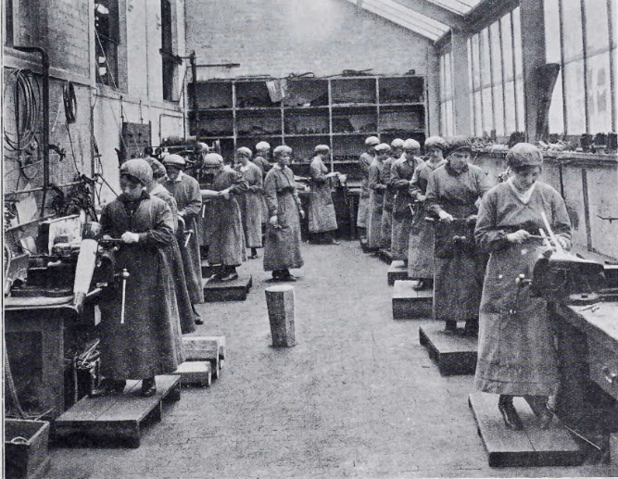

Figure 3: Cover photo of TWE’s fourth issue showing Scottish women making artificial limbs (Haslett 1920, 31)

- Strategy in Establishing Legitimacy

Even if women were confident in their abilities, they still had to convince society at large that they had a rightful claim to their place in engineering. In seeking legitimacy, TWE focussed on three main matters: education, membership in technical institutions, and endorsements from well-respected (male) engineers. It is noted that the common attribute between all three is that they are all a form of acknowledgment of one’s abilities from an external party that has great standing in society. Hence, they were less liable to dispute or distortion by the skilled trades unions as opposed to, for example, the definition of ‘skilled’ work which was largely controlled by the unions.

TWE wrote extensively about education and its importance for women who were interested in engineering. The articles ‘The Training of a CIvil Engineer’ by Iris A. Cummins from the first issue and ‘The Magic of Mathematics’ by Elizabeth H. M. Georgeson, B.Sc. (Engineering) from the fourth issue, all touch on the importance of a scientific higher education not only as a qualification but also in the work of an engineer. An important thing to highlight here is that the writers of these articles were pioneering women engineers; Iris Cummins and Elizabeth Georgeson were the first women to graduate in engineering from the present-day University College Cork and a Scottish university respectively. This is important as these women were not only able to give pertinent advice to the readers, but also serve as proof that they could study engineering at a higher level.

Of all the topics covered in TWE, the two most consistently discussed were the admission of women into technical institutions and endorsements from established engineers. At the start of every issue, TWE would list the technical institutions which had recently allowed women membership and the women who were admitted into them, such as the North East Coast Institution of Engineers and Shipbuilders, the Institution of Electrical Engineers, and the Society of Technical Engineers. Besides that, TWE ran a regular series of articles from the second issue onwards titled ‘Views of Distinguished Engineers’ which were written by influential engineering employers such as Sir Charles Parsons, who has already been mentioned above; Lord Weir of Eastwood, then chairman of the G. and J. Weir engineering firm; and Sir William Beardmore. In these articles, not only did these employers write positively about women’s employment in engineering, but often stressed the dire repercussions on the nation if women were excluded. The latter is most evident in the following excerpt from Lord Weir’s writing below.

Unless we can broaden the labour supply of this country, its production capacity will be insufficient to meet the needs of the Empire, and our world Trade, on which our prosperity depends, will pass to more imaginative and more enterprising nations (Haslett 1920, 24).

This was intended to be persuasive for both women and general society as it demonstrated the belief these respected men had on the crucial role women could play economically and sociopolitically if they were allowed into engineering.

References and Acknowledgements

Andrews, Irene O. 1921. The Economic Effects of the World War Upon Women and Children in Great Britain. 2nd ed. New York: Oxford University Press.

Braybon, Gail. 2012. Women Workers in the First World War. London: Taylor & Francis.

Haslett, Caroline, ed. 1919. The Woman Engineer 1, no. 1 (December). https://twej.theiet.org/twej/WES_Vol_1.html.

Haslett, Caroline, ed. 1920. The Woman Engineer 1, no. 2 (March). https://twej.theiet.org/twej/WES_Vol_1.html.

Haslett, Caroline, ed. 1920. The Woman Engineer 1, no. 3 (June). https://twej.theiet.org/twej/WES_Vol_1.html.

Haslett, Caroline, ed. 1920. The Woman Engineer 1, no. 4 (September). https://twej.theiet.org/twej/WES_Vol_1.html.

Acknowledgements are due to the IET Archives and WES for allowing the reproduction of pictures and quotes from The Woman Engineer’s digital archives, specifically the first to fourth issues of the journal, for this research project. Next, many many thanks to my History of Science supervisors, Morgan Breene, Madeline White, and Erica Charters, for all the time and effort put into supervising this research project and internship as a whole - all the input and comments have made this entire internship a fruitful and rewarding one. Many thanks too are due to my Materials Science supervisors Angus Wilkinson, Dave Armstrong, and Susie Speller for being so supportive throughout the project. I would also like to thank Jo Knights for being there and being so understanding. I would like to thank all the other fellow interns for being there throughout the journey - we did it! And finally, to everyone else who was involved in ways big or small that I have not mentioned in hopes of ensuring this paragraph does not run too long - thank you so much!

