Mentoring Overview

Mentoring – what is it?
Is to facilitate the mentee's growth and development by offering valuable insights, sharing experiences, and assisting them in navigating various challenges and opportunities.
Mentors act as role models and provide encouragement, constructive feedback, and practical advice to help the mentee enhance their skills, knowledge, and confidence.
Primary goal of mentoring
- Mentoring is a dynamic and supportive relationship between two individuals, where one person (the mentor) provides guidance, advice, and support to another person (the mentee) to help them develop personally, professionally, or academically.
- The mentor is usually someone who possesses more knowledge, experience, and expertise in a particular field or domain than the mentee, although peer-to peer mentoring is also a valid mentoring relationship.
- Mentoring is not a replacement for line management, supervision, appraisal or PDR, performance management or support in cases of harassment or grievance. Neither is mentoring counselling or therapy - although the mentor may help the mentee to access more specialised support if it becomes apparent that this is needed.
- The mentor does not act on behalf of the mentee. It is the mentee’s responsibility to act and, where relevant, the mentors to assist the mentee in reaching decisions about an action and/or reflect upon the consequences of the action.

Key aspects of mentoring
Key aspects of a mentoring relationship include:
Mentoring can be a highly rewarding experience for both the mentor and the mentee, as it fosters mutual learning, growth, and the opportunity to make a positive impact on someone's life and career.
- Support: The mentor provides emotional and professional support to the mentee, fostering a positive and nurturing environment for growth.
- Guidance: The mentor offers valuable insights, expertise, and knowledge to help the mentee make informed decisions and overcome challenges.
- Networking: Mentors often introduce mentees to relevant contacts and networks to expand their connections and opportunities.
- Personal Development: Mentoring goes beyond just skill development; it also focuses on personal growth and building confidence.
- Feedback: The mentor provides constructive feedback and helps the mentee identify areas for improvement and development.
- Empowerment: The ultimate aim of mentoring is to empower the mentee to achieve their goals and reach their full potential.

How mentoring works
The mentoring process typically follows a structured framework, but it can also be flexible and adapted to the specific needs and goals of the participants. Here is a general outline of how the mentoring process works:
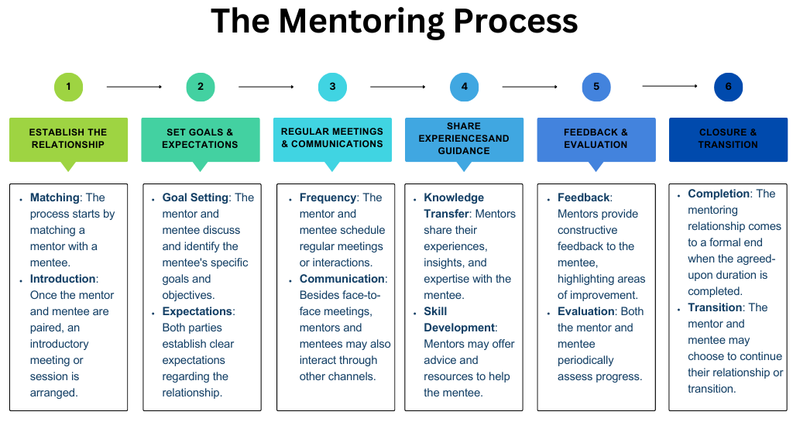
Establishing the Relationship:
- Matching: The process starts by matching a mentor with a mentee based on their shared interests, expertise, and goals. In some cases, participants may have the option to choose their mentors or mentees, while in others, a program coordinator may handle the matching process.
- Introduction: Once the mentor and mentee are paired, an introductory meeting or session is arranged to help them get to know each other, build rapport, and establish the foundation for the mentoring relationship.

Setting Goals and Expectations:
The mentoring process is a dynamic and evolving journey, and it relies on open communication, trust, and commitment from both the mentor and the mentee.
It's essential to be flexible and adaptable, as each mentoring relationship is unique and may require different approaches and strategies.
The mentoring Process
- Goal Setting: The mentor and mentee discuss and identify the mentee's specific goals and objectives for the mentoring relationship. These goals can be related to personal development, career advancement, skill enhancement, or any other area the mentee wishes to focus on.
- Expectations: Both parties establish clear expectations regarding the frequency of meetings, communication channels, confidentiality, and any other guidelines necessary to ensure a productive and respectful mentoring relationship.
Regular Meetings and Communication:
- Frequency: The mentor and mentee schedule regular meetings or interactions to discuss progress, challenges, and any other relevant topics. The frequency of meetings can vary, depending on the availability and preferences of both individuals.
- Communication: Besides face-to-face meetings, mentors and mentees may also interact through phone calls, emails, video conferencing, or messaging platforms, as appropriate.
Knowledge Sharing and Guidance:
- Knowledge Transfer: Mentors share their experiences, insights, and expertise with the mentee. They may provide guidance on navigating career choices, overcoming obstacles, and seizing opportunities.
- Skill Development: Mentors may offer advice and resources to help the mentee enhance their skills, knowledge, and competencies in specific areas.

Feedback and Evaluation:
- Feedback: Mentors provide constructive feedback to the mentee, highlighting areas of improvement and acknowledging achievements. The feedback is essential for the mentee's growth and development.
- Evaluation: Both the mentor and mentee periodically assess the progress of the mentoring relationship, ensuring that it remains valuable and effective. Adjustments to the goals and approach may be made if necessary.
Closure and Transition:
- Completion: The mentoring relationship comes to a formal end when the agreed-upon duration is completed or when both parties feel that their goals have been achieved.
- Transition: The mentor and mentee may choose to continue their relationship informally or transition into a different type of relationship, such as becoming professional colleagues or friends.

Benefits of mentoring
Overall, mentoring is a valuable and mutually beneficial relationship that fosters personal and professional growth, facilitates knowledge transfer, and contributes to the success of both individuals involved.

benefits
Mentoring offers a wide range of benefits for both the mentee and the mentor. Here are some of the key advantages of mentoring:
1. Knowledge and Skill Development: Mentees gain access to the knowledge, experience, and expertise of their mentors, allowing them to learn new skills, acquire valuable insights, and develop competencies relevant to their personal or professional growth.
2. Career Advancement: Mentoring can provide mentees with guidance on career choices, opportunities, and advancement strategies. Mentors can offer advice on building a career path, navigating challenges, and making informed decisions.
3. Increased Confidence: As mentees receive support and encouragement from their mentors, they often experience increased self-confidence and belief in their abilities, which can lead to greater achievements.
4. Expanded Network: Mentoring relationships often facilitate networking opportunities, as mentors can introduce mentees to their professional contacts and help expand their network.
5. Personal Growth: Mentoring goes beyond professional development and also focuses on personal growth. Mentees can gain a better understanding of their strengths, weaknesses, and values, leading to enhanced self-awareness and personal fulfilment.
6. Constructive Feedback: Mentors provide constructive feedback to mentees, highlighting areas for improvement and helping them identify blind spots. This feedback is crucial for mentees' continuous improvement.
7. Decision Making Support: Mentors can assist mentees in making better-informed decisions by offering different perspectives, weighing pros and cons, and considering potential outcomes.
8. Role Modelling: Mentors serve as role models for mentees, showcasing successful behaviours, ethical practices, and leadership qualities that mentees can emulate.
9. Organisational Benefits: In workplace mentoring programs, organisations can benefit from improved employee satisfaction, higher retention rates, enhanced knowledge sharing, and a more positive company culture.
10. Personal Fulfilment for Mentors: Mentoring can be a rewarding experience for mentors, as they witness the growth and success of their mentees, fostering a sense of fulfilment and making a positive impact on someone's life.
11. Enhanced Leadership Skills for Mentors: Mentors often develop and refine their leadership and coaching skills through the mentoring process, which can benefit them in their professional roles.
12. Knowledge Transfer and Legacy: Mentoring allows mentors to pass on their expertise and knowledge to the next generation, contributing to the continuity of skills and expertise within a field or industry.

Additional mentoring resources within The University of Oxford
https://www.rdm.ox.ac.uk/intranet/career-development/mentoring
https://pod.admin.ox.ac.uk/mentoring.
Any questions? Contact training@mpls.ox.ac.uk
For information on mentoring within MPLS departments please visit this web page. https://www.mpls.ox.ac.uk/training/mentoring-in-mpls/mentoring-in-departments

